**MBAN 5220 Assignment 1**

**Chapter 2 Level I and II Exercises**

1 a) b)

**data** work.price_increase;

set orion.prices;

Year = **1**;

Unit_Price = Unit_Price * Factor;

output;

Year = **2**;

Unit_Price = Unit_Price * Factor;

output;

Year = **3**;

Unit_Price = Unit_Price * Factor;

output;

**run**;

**proc** **print** data = work.price_increase;

var Product_ID Unit_Price Year;

**run**;

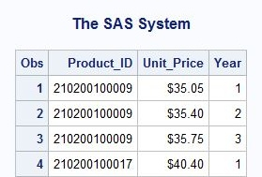

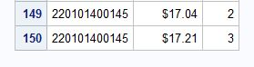

2 a) b)

**data** work.extended;

set orion.discount;

drop unit_sales_price;

where Start_Date = **'01dec2011'd**;

Promotion = 'Happy Holidays';

Season = 'Winter';

output;

Start_Date = **'01jul2012'd**;

End_Date = **'31jul2012'd**;

Season = 'Summer';

output;

**run**;

title 'All discount ranges with the Happy Holidays promotion';

**proc** **print** data = work.extended;

**run**;

title;

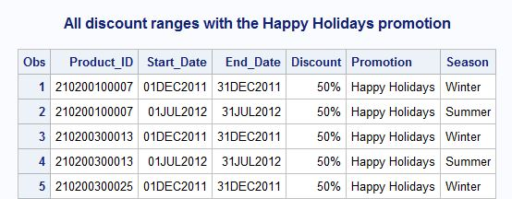

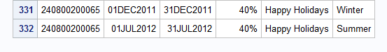

4 a)

**data** work.admin work.stock work.purchasing;

set orion.employee_organization;

if Department = 'Administration' then output work.admin;

else if Department = 'Stock & Shipping' then output work.stock;

else if Department = 'Purchasing' then output work.purchasing;

**run**;

b)

title 'Administration Employees';

**proc** **print** data=work.admin;

**run**;

title;

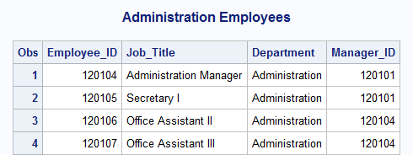

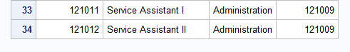

4 c)

title 'Stock and Shipping Employees';

**proc** **print** data = work.stock;

**run**;

title;

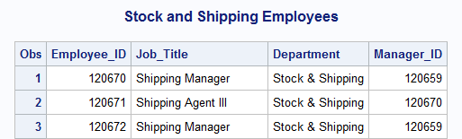

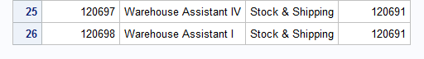

d)

title 'Purchasing Employees';

**proc** **print** data = work.purchasing;

**run**;

title;

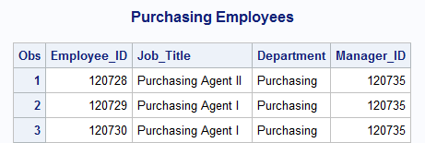

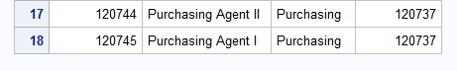

5 a)

**data** work.fast work.slow work.veryslow;

set orion.orders;

where Order_Type in (**2**,**3**);

ShipDays = Delivery_Date - Order_Date;

if ShipDays < **3** then output work.fast;

else if **5** <= ShipDays <= **7** then output work.slow;

else if ShipDays > **7** then output work.veryslow;

drop Employee_ID;

**run**;

b)

title 'Orders requiring more than 7 days to deliver';

**proc** **print** data = work.veryslow;

**run**;

title;

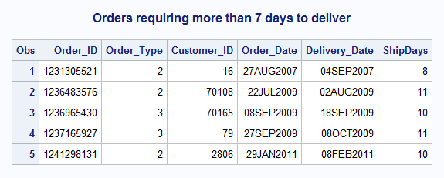

7 a)

**data** work.sales (keep = Employee_ID Job_Title Manager_ID)

work.exec (keep = Employee_ID Job_Title);

set orion.employee_organization;

if Department = 'Sales' then output work.sales;

else if Department = 'Executives' then output work.exec;

**run**;

205 data work.sales (keep = Employee_ID Job_Title Manager_ID)

206 work.exec (keep = Employee_ID Job_Title);

207

208 set orion.employee_organization;

209 if Department = 'Sales' then output work.sales;

210 else if Department = 'Executives' then output work.exec;

211 run;

NOTE: There were 424 observations read from the data set

ORION.EMPLOYEE_ORGANIZATION.

NOTE: The data set WORK.SALES has 201 observations and 3 variables.

NOTE: The data set WORK.EXEC has 4 observations and 2 variables.

NOTE: DATA statement used (Total process time):

real time 0.03 seconds

cpu time 0.01 seconds

b)

title 'Sales Employees';

**proc** **print** data = work.sales (obs = **6**);

**run**;

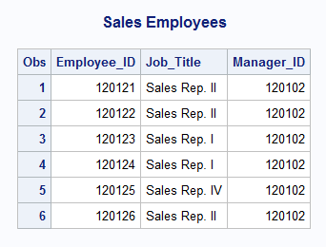

7 c)

title 'Executives';

**proc** **print** data = work.exec (firstobs = **2** obs = **3**);

**run**;

title;

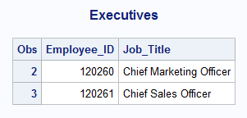

8 a)

**data** work.instore (keep = Order_ID Customer_ID Order_Date)

work.delivery (keep = Order_ID Customer_ID Order_Date ShipDays);

set orion.orders (obs = **30**);

where Order_Type = **1**;

ShipDays = Delivery_Date-Order_Date;

if ShipDays = **0** then output work.instore;

else if ShipDays > **0** then output work.delivery;

**run**;

212 data work.instore (keep = Order_ID Customer_ID Order_Date)

213 work.delivery (keep = Order_ID Customer_ID Order_Date ShipDays);

214

215 set orion.orders (obs = 30);

216 where Order_Type = 1;

217

218 ShipDays = Delivery_Date-Order_Date;

219

220 if ShipDays = 0 then output work.instore;

221 else if ShipDays > 0 then output work.delivery;

222 run;

NOTE: There were 30 observations read from the data set ORION.ORDERS.

WHERE Order_Type=1;

NOTE: The data set WORK.INSTORE has 28 observations and 3 variables.

NOTE: The data set WORK.DELIVERY has 2 observations and 4 variables.

NOTE: DATA statement used (Total process time):

real time 0.03 seconds

cpu time 0.01 seconds

8 b)

**data** work.instore (keep = Order_ID Customer_ID Order_Date)

work.delivery (keep = Order_ID Customer_ID Order_Date ShipDays);

set orion.orders;

where Order_Type = **1**;

ShipDays=Delivery_Date-Order_Date;

if ShipDays = **0** then output work.instore;

else if ShipDays > **0** then output work.delivery;

**run**;

224 data work.instore (keep = Order_ID Customer_ID Order_Date)

225 work.delivery (keep = Order_ID Customer_ID Order_Date ShipDays);

226

227 set orion.orders;

228 where Order_Type = 1;

229

230 ShipDays = Delivery_Date-Order_Date;

231

232 if ShipDays = 0 then output work.instore;

233 else if ShipDays > 0 then output work.delivery;

234 run;

NOTE: There were 260 observations read from the data set ORION.ORDERS.

WHERE Order_Type=1;

NOTE: The data set WORK.INSTORE has 250 observations and 3 variables.

NOTE: The data set WORK.DELIVERY has 10 observations and 4 variables.

NOTE: DATA statement used (Total process time):

real time 0.05 seconds

cpu time 0.01 seconds

c)

title 'Deliveries from In-store Purchases';

**proc** **print** data = work.delivery;

**run**;

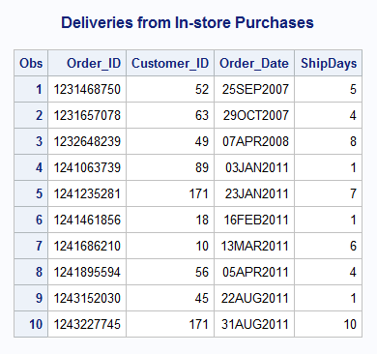

8 d)

title 'In-stock Store Purchases, By Year';

**proc** **freq** data = work.instore;

tables Order_Date;

format Order_Date year.;

**run**;

title;

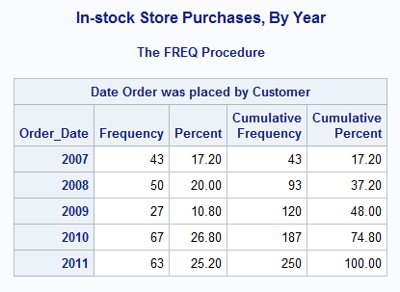

**Chapter 3 Level I and II Exercises**

1 a)

**data** work.mid_q4;

set orion.order_fact;

where **'01nov2008'd** <= Order_Date <= **'14dec2008'd**;

Sales2Dte + Total_Retail_Price;

Num_Orders + **1**;

**run**;

b)

title 'Orders from 01Nov2008 through 14Dec2008';

**proc** **print** data = work.mid_q4;

format Sales2Dte dollar10.2;

var Order_ID Order_Date Total_Retail_Price Sales2Dte Num_Orders;

**run**;

title;

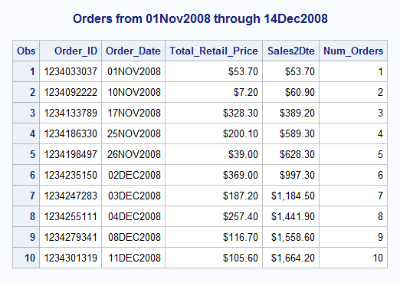

2 a)

**data** work.typetotals;

set orion.order_fact (obs = **10**);

where year(Order_Date) = **2009**;

if Order_Type = **1** then TotalRetail + Quantity;

else if Order_Type = **2** then TotalCatalog + Quantity;

else if Order_Type = **3** then TotalInternet + Quantity;

**run**;

2 b)

**proc** **print** data = work.typetotals;

**run**;

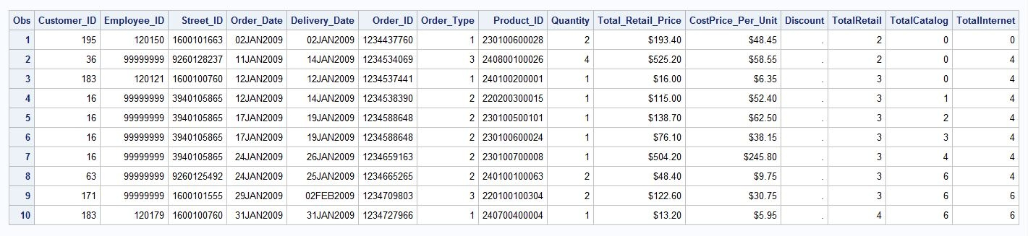  
  
 c)

**data** work.typetotals;

set orion.order_fact (obs = **10**);

where year(Order_Date) = **2009**;

if Order_Type = **1** then TotalRetail + Quantity;

else if Order_Type = **2** then TotalCatalog + Quantity;

else if Order_Type = **3** then TotalInternet + Quantity;

keep Order_ID Order_Date TotalRetail TotalCatalog TotalInternet;

**run**;

title '2009 Total Items Sold by Order Type';

**proc** **print** data = work.typetotals;

**run**;

title;

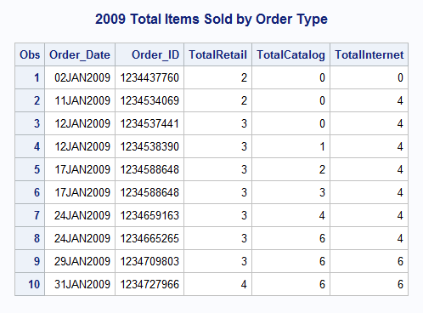

4 a)

**proc** **sort** data = orion.order_summary out = work.sumsort;

by Customer_ID;

**run**;

309 proc sort data = orion.order_summary out = work.sumsort;

310 by Customer_ID;

311 run;

NOTE: There were 101 observations read from the data set ORION.ORDER_SUMMARY.

NOTE: The data set WORK.SUMSORT has 101 observations and 3 variables.

NOTE: PROCEDURE SORT used (Total process time):

real time 0.12 seconds

cpu time 0.06 seconds

b)

**data** work.customers;

set work.sumsort;

by Customer_ID;

if first.Customer_ID then Total_Sales = **0**;

Total_Sales + Sale_Amt;

if last.Customer_ID;

keep Customer_ID Total_Sales;

**run**;

313 data work.customers;

314 set work.sumsort;

315 by Customer_ID;

316 if first.Customer_ID then Total_Sales = 0;

317

318 Total_Sales + Sale_Amt;

319

320 if last.Customer_ID;

321 keep Customer_ID Total_Sales;

322 run;

NOTE: There were 101 observations read from the data set WORK.SUMSORT.

NOTE: The data set WORK.CUSTOMERS has 37 observations and 2 variables.

NOTE: DATA statement used (Total process time):

real time 0.01 seconds

cpu time 0.00 seconds

4 c)

title 'Total Sales to each Customer';

**proc** **print** data = work.customers;

format Total_Sales dollar11.2;

**run**;

title;

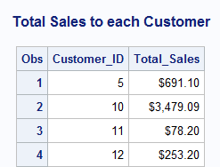

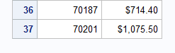

5 a)

**proc** **sort** data = orion.order_qtrsum out = work.custsort;

by Customer_ID Order_Qtr;

**run**;

**data** work.qtrcustomers;

set work.custsort;

by Customer_ID Order_Qtr;

if first.Order_Qtr = **1** then do;

Total_Sales = **0**;

Num_Months = **0**;

end;

Total_Sales + Sale_Amt;

Num_Months + **1**;

if last.Order_Qtr = **1**;

keep Customer_ID Order_Qtr Total_Sales Num_Months;

**run**;

5 b)

title 'Total Sales to each Customer by Quarter';

**proc** **print** data = work.qtrcustomers;

format Total_Sales dollar11.2;

**run**;

title;

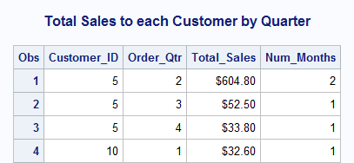

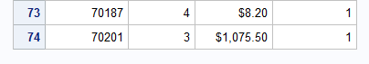  
  
  
6 a)

**proc** **sort** data = orion.usorders04 out = work.usorders04;

by Customer_ID Order_Type;

**run**;

**data** work.discount1 work.discount2 work.discount3;

set work.usorders04;

by Customer_ID Order_Type;

if first.Order_Type = **1** then TotSales = **0**;

TotSales + Total_Retail_Price;

if last.Order_Type = **1** and TotSales >= **100** then do;

if Order_Type = **1** then output discount1;

else if Order_Type = **2** then output discount2;

else if Order_Type = **3** then output discount3;

end;

keep Customer_ID Customer_Name TotSales;

**run**;

357 proc sort data = orion.usorders04 out = work.usorders04;

358 by Customer_ID Order_Type;

359 run;

NOTE: There were 83 observations read from the data set ORION.USORDERS04.

NOTE: The data set WORK.USORDERS04 has 83 observations and 9 variables.

NOTE: PROCEDURE SORT used (Total process time):

real time 0.04 seconds

cpu time 0.03 seconds

360

361 data work.discount1 work.discount2 work.discount3;

362 set work.usorders04;

363 by Customer_ID Order_Type;

364

365 if first.Order_Type = 1 then TotSales = 0;

366

367 TotSales + Total_Retail_Price;

368

369 if last.Order_Type = 1 and TotSales >= 100 then do;

370 if Order_Type = 1 then output discount1;

371 else if Order_Type = 2 then output discount2;

372 else if Order_Type = 3 then output discount3;

373 end;

374

375 keep Customer_ID Customer_Name TotSales;

376 run;

NOTE: There were 83 observations read from the data set WORK.USORDERS04.

NOTE: The data set WORK.DISCOUNT1 has 8 observations and 3 variables.

NOTE: The data set WORK.DISCOUNT2 has 2 observations and 3 variables.

NOTE: The data set WORK.DISCOUNT3 has 5 observations and 3 variables.

NOTE: DATA statement used (Total process time):

real time 0.04 seconds

cpu time 0.00 seconds

6 b)

title 'Customers Spending $100 or more in Retail Orders’;

**proc** **print** data = work.discount1 noobs;

format TotSales dollar11.2;

**run**;

title;

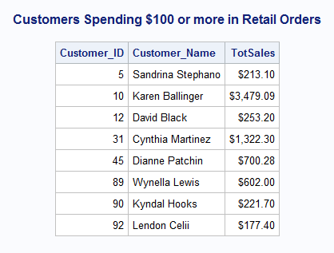

**Chapter 4.1 Level I and II Exercises**

1 a)

**data** sales_staff;

infile "&path\sales1.dat";

input @**1** Employee_ID **6.**

@**21** Last_Name $18.

@**43** Job_Title $20.

@**64** Salary Dollar8.

@**87** Hire_Date mmddyy10.;

**run**;

440 data sales_staff;

441 infile "&path\sales1.dat";

442 input @1 Employee_ID 6.

443 @21 Last_Name $18.

444 @43 Job_Title $20.

445 @64 Salary Dollar8.

446 @87 Hire_Date mmddyy10.;

447 run;

NOTE: The infile "c:\sas\prg2\sales1.dat" is:

Filename=c:\sas\prg2\sales1.dat,

RECFM=V,LRECL=32767,File Size (bytes)=26730,

Last Modified=January 11, 2016 15:03:41 o'cl,

Create Time=January 11, 2016 15:02:28 o'cl

NOTE: 165 records were read from the infile "c:\sas\prg2\sales1.dat".

The minimum record length was 160.

The maximum record length was 160.

NOTE: The data set WORK.SALES_STAFF has 165 observations and 5 variables.

NOTE: DATA statement used (Total process time):

real time 0.12 seconds

cpu time 0.03 seconds

1 b)

title 'Australian and US Sales Staff';

**proc** **print** data = sales_staff noobs;

**run**;

title;

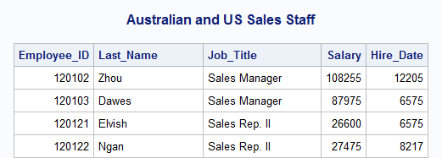

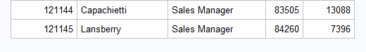

2 a)

**data** AU_trainees US_trainees;

drop Country;

infile "&path\sales1.dat";

input @**1** Employee_ID **6.**

@**21** Last_Name $18.

@**43** Job_Title $20.

@**64** Salary Dollar8.

@**73** Country $2.

@**87** Hire_Date mmddyy10.;

if Job_Title = 'Sales Rep. I';

if Country = 'AU' then output AU_trainees;

else if Country = 'US' then output US_trainees;

**run**;

b)

title 'Australian Trainees';

**proc** **print** data = AU_trainees noobs;

**run**;

title 'US Trainees';

**proc** **print** data = US_trainees noobs;

**run**;

title;

492 title 'Australian Trainees';

493 proc print data = AU_trainees noobs;

494 run;

NOTE: There were 21 observations read from the data set WORK.AU_TRAINEES.

NOTE: PROCEDURE PRINT used (Total process time):

real time 0.03 seconds

cpu time 0.01 seconds

495

496 title 'US Trainees';

497 proc print data = US_trainees noobs;

498 run;

NOTE: There were 42 observations read from the data set WORK.US_TRAINEES.

NOTE: PROCEDURE PRINT used (Total process time):

real time 0.04 seconds

cpu time 0.03 seconds

